Chemistry 11 Name: ____________________________
Unit 2 – Atoms and Molecules Date: __________________Block: _____

MIDYEAR EXAM REVIEW

It is expected that you will be able to:
- relate the observable properties and characteristics of elements, compounds, and mixtures to the concept of atoms and molecules
- classify a given material as an element, compound, or mixture, using the properties of the material
- describe a pure substance as having a set of unique and identifiable properties
- differentiate between atoms, molecules, and ions

- write the names and formulae for ionic and covalent compounds, given appropriate charts or data tables
- derive a chemical name, given a formula, periodic table, and table of common ions
- derive a formula (or symbol), given a chemical name, periodic table, and table of common ions
- name and write formulae for some common acids and bases
- use the prefix naming system for covalent compounds

- describe the characteristics of matter
- describe chemistry as the science concerned with the properties, composition, and behaviour of matter
- classify a substance as solid, liquid, or gas, and describe its different properties
- define the terms, matter, boiling point, freezing point, and melting point
- state the kinetic molecular theory
- describe the simple molecular motions and arrangements of particles in solids, liquids, and gases

- differentiate between physical and chemical changes
- describe the types of changes that may be observed when matter is heated, cooled, combined, or separated
- relate the heat changes that occur during phase changes to changes in molecular motions and arrangements

- select an appropriate way of separating the components of a mixture
- use various mechanical means to separate components of a mixture, including filtration, evaporation, chromatography, and distillation
- relate the method of separation to the properties of the mixture’s components

- describe the development of the model of the atom
- describe changes in the model of the atom as a result of the work of Dalton, Thomson, Rutherford, and Bohr

- describe the sub-atomic structures of atoms, ions, and isotopes, using calculation where appropriate
- describe the relative position, mass, and charge for a proton, neutron, and electron
- identify the atomic number of an element, using a table
- describe a simple electron arrangement for the first 20 elements
- define isotope
- calculate the number of neutrons, protons, and electrons for an atom or ion, given the mass number of the isotope and the charge of the ion
- calculate the average atomic mass from isotopic data
- describe the development of the modern periodic table
- explain the significance of the work of Mendeleev
- distinguish the ordering of elements in early periodic tables (based on atomic mass) from the ordering of elements in the modern periodic table (based on atomic number)

- draw conclusions about the similarities and trends in the properties of elements, with reference to the periodic table
- classify elements as metal, non-metal, or metalloid and locate them on the periodic table
- describe trends in properties such as melting point, ionization energy, atomic radius, chemical reactivity, ion charge, and conductivity
- identify the following families of elements: alkali metals, alkaline earth metals, halogens, noble gases, transition metals
- describe some properties of the alkali metals, alkaline earth metals, halogens, noble gases, and transition metals
- predict the characteristics of elements knowing the characteristics of another element in that family
- predict the formulae of compounds given the formula of another compound containing elements in the same families

- justify chemical and physical properties in terms of electron configuration
- relate noble gas stability to electron arrangement within the atom
- predict the probable electron gain or loss for elements in columns 1, 2, 13, 15, 16, and 17
- relate the observed charge of monatomic ions of metals and non-metals to numbers of electrons lost or gained
- define valence electrons

- demonstrate knowledge of various types of chemical bonding
- define covalent, ionic bonding, polar covalent and metallic bonds
- be able to classify a compounds bond type using electronegativities
- recognize the connection between bonding and valence electrons
- be able to predict the strength of ionic or covalent bonds
- be able to predict the melting and boiling points of ionic and covalent compounds
- predict ion size

- apply understanding of bonding to create formulae and Lewis structures
- identify from a chemical formula the probable type of bond (ionic or covalent)
- draw an electron dot diagram (Lewis structures) for an atom, ion, or molecule
- draw structural formulae for simple molecules and ions, and deduce molecular geometry using VSEPR

It is expected that you will be able to:
- demonstrate skills in measuring and in recording data
- use SI units and their accepted alternatives in chemistry
- recognize the imprecise nature of all measurements
- determine the number of significant figures in a measured quantity and relate to its uncertainty
- round off calculated results to the appropriate number of significant figures
- correctly determine the unit of a derived quantity (unit analysis)

Make sure you bring:
- your calculator
- pencils for SCANTRON and eraser
- pen or pencil for written
1. Describe solids, liquids and gases according the Kinetic Molecular Theory:
 | solids | liquids | gas
mass
shape
volume
arrangement of particles
movement of particles

2. Outline the Classification of Matter using the terms pure substance, element, compound, mixture,
homogeneous mixture and heterogenous mixture.

4. Classify each of the following as a pure substance, homogenous mixture (solution) or heterogenous mixture:

lemonade |  | chocolate chip cookie
ocean water |  | distilled water
gasoline |  | brass
air |  | salt
oxygen |  | iron

5. What are the parts of a solution? Is it considered a homogeneous or heterogeneous mixture? Why?

6. Label the states of matter in the following heating curve for the unknown substance.
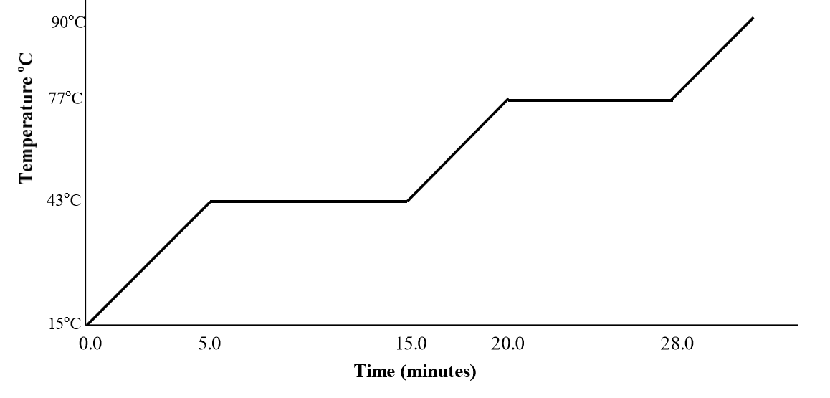
- What is the melting point (freezing point) of this substance? ______________________________

- What is the boiling point (condensation point) of this substance? __________________________

- Use arrow to label increasing kinetic energy and decreasing kinetic energy in the graph.

- Explain why the curve is flat between 5.0 min and 15.0 min.

- Explain which kinetic energy (E_{ROT}, E_{VIB} and E_{TRANS}) change is most important during a phase change.

9a. Explain how distillation can be used to separate the substances in a solution.

b. What types of mixtures does chromatography work best for?

c. Solvent extraction involves using two different solvents which are (miscible/immiscible) _______________.

d. Explain how a centrifuge separates the components of a suspension.

10. Separate the following mixture. Remember, ALL components of the mixture must be saved in order to
receive full marks.

2g black sand
2g sugar
1g alcohol (boiling point is 58°C)
2g fine iron granules

** The sand and the iron granules are the SAME SIZE**

12. Complete the following table:

Element/Ion | Atomic Number | Atomic Mass | Protons | Neutrons | Electrons
 |  |  | 14 |  | 0
$${Cl}^{-}$$ |  |  | 17
$${}_{7}^{14}N$$ |  |  | 6
 | 26 |  |  |  | 24
$$X^{-1}$$ |  |  |  |  | 10
$${}_{11}^{23}{Na}$$ |  |  |  |  | 11
13. Determine the average atomic mass of the following isotope mixtures

72.2% 85-Rb and 27.8% 87-Rb

0.01% of 234-U, 0.71% of 235-U and 99.28% of 238-U

14. Write out the electron configurations of the following atoms/ions using full notation.

Cu:

Mg⁺²:

O⁻²:

15. Write out the electron configuration using core notation for the following atoms and ions.

Br:

Ni:

Au⁺²:

Cl⁻¹:

16. Use the electron configuration to determine the number of valence electrons in the atoms below.

P:

Ni:

Ne:

17a. Fill in the following tables regarding Periodic Table Trends.

Property | Increasing or Decreasing Trend Across a Period (LR) | Explanation for Trend
Atomic Radius

Electronegativity
Ionization Energy

Property | Increasing or Decreasing Trend Down a Family (Top Bottom) | Explanation for Trend
Atomic Radius

Electronegativity
Ionization Energy

b. Describe the properties of metals and non-metals:

Metals | Non-metals

18. Identify the element in the following pairs with the larger atomic radius:

N or P ? N or F?

Arrange the following atoms in order of increasing ionization energy: Br, F, Cl, I, At

19. Write the correct name for the following formulas:

PbCrO₄ • 6H₂O |  | ammonium chlorate
As₂O₃ |  | copper (II) sulphite
HNO₃ |  | zinc carbonate tetrahydrate
MgC₂O₄ |  | hydrochloric acid
H₃PO₄ |  | phosphorus pentaiodide
NH₄HCO₃ |  | iron (III) hydroxide
NF₃ |  | dinitrogen tetrafluoride

20. Draw the best Lewis Structures and the name of the molecular geometry (VSEPR) for the following:

 | # of valence electrons | Lewis Structure | VSEPR
NH₃

OF₂

CH₄

SiH₄

21. In an experiment, you measured that the thickness of aluminum foil is 1.1 x 10⁻² cm. The accepted value for manufacturers is 1.06 x 10⁻². Is your measured value accurate? Precise? Explain.

22. Convert the following

- 0.0006 mm = ? μm

- 0.054 mL = ? nL

- 3.5 μg/mL = ?cg/dL

23. Give the number of significant digits in each of the following. Assume they are all measurements.

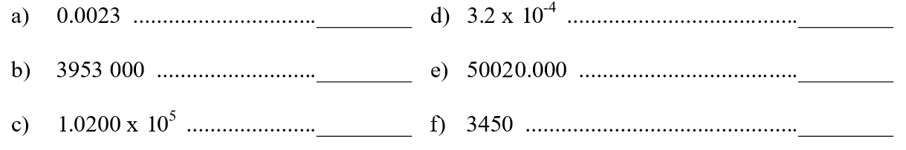

24. Round the following numbers to 3 significant figures.
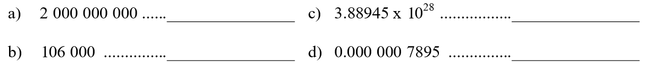

24. Perform the following calculations and round the answers off to the correct number of significant figures as justified by the data. Assume all numbers are measurements.

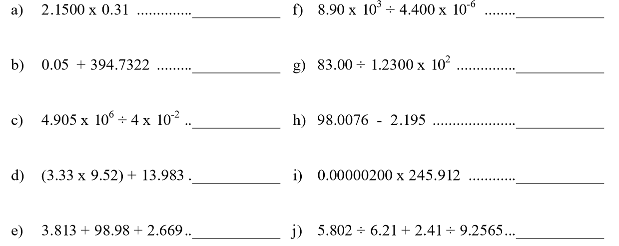

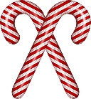
25. Mrs. Pasta recorded the masses of 5 candy canes as follows:

1.06 g 1.21 g 1.23 g 1.01 g 1.12 g

Calculate the average mass of a candy cane with uncertainty.

26. Last night’s overnight temperature was recorded to be 1.5 $±$ 0.5°C. What temperature range does this represent?

27. What are the measurements of the following with uncertainty?
- b.
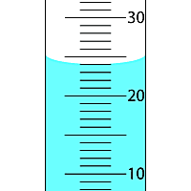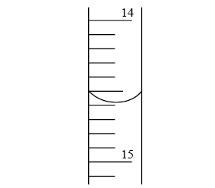
Multiple Choice Questions:

1. In which state of matter are the particles very close together, but vibrating?
- Solid
- Liquid
- Gas
- Plasma

2. When you mix water and alcohol together, the result is:
- a compound
- a heterogenous mixture
- a homogenous mixture
- a pure substance

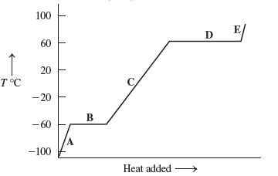
3. Look at the following Temperature vs. Time graph. Which of the statements below is true?

- Section “A” – both solid and liquid are present.
- Section “B” – energy is being used primarily for melting.
- Section “C” – all three states of matter are present.
- Section “D” – only gas is present.

4. Which of the following is a characteristic of a pure substance?
- They are solutions.
- They are composed of one element.
- They have more than one element.
- They cannot be broken down into other substances.

5. When the early miners used to pan for gold in the rivers, what separation technique were they using?
- Mechanical separation
- Gravity separation
- Filtration
- Fractional distillation
6. Using a magnet to separate iron nails from aluminum nails is a type of
- Mechanical separation
- Gravity separation
- Filtration
- Fractional distillation

7. The process by which a mixture is carried by a solvent through a stationary porous medium (like filter paper) is called:
- Extraction
- Filtration
- Chromatography
- Fractional distillation

8. Atoms of the same element are said to be isotopes of each other if:
- The number of protons is equal to the number of neutrons.
- The number of neutrons is not equal to the number of electrons.
- The number of protons is not equal to the number of neutrons.
- The number of protons is not equal to the number of electrons.

9. A true statement about atoms is:
- Most of the volume of an atom is empty space.
- The nucleus contains the neutrons and the electrons.
- The mass of an atom is evenly distributed throughout its volume.
- All atoms occupy the same volume.

10. The electron configuration: 1s² 2s² 2p⁶ 3s² 3p⁶ 4s² 3d² belongs to which of the following:
- An atom of titanium
- An ion of chromium with a charge of -2
- A Mo ion with a charge of +2
- An atom of silicon

11. Electronegativity is the:
- Ability to form a bond between metallic and non-metallic atoms.
- Ability of an atom to attract other atoms.
- Force of attraction which non-metallic atoms have for free electrons.
- Force of attraction that an atom has for a pair of electrons in a covalent bond.

12. The element with the highest ionization energy is:
- Sc
- Cr
- Fe
- Se

13. How many valence electrons are there in an atom of Bromine?
- 35
- 17
- 7
- 1

14. Given the atomic mass of 207 and an atomic number of 82, an atom of lead contains:
- 125 protons, 82 neutrons, 82 electrons
- 207 protons, 82 neutrons, 201 electrons
- 82 protons, 125 neutrons, 82 electrons
- 82 protons, 82 neutrons, 125 electrons

15. The formula for dinitrogen tetroxide is:
- N₄O₂
- N₂O₅
- N₂O₄
- NO₂

16. The formula for cobalt (III) cyanide is:
- CoCN₃
- Co(CN)₃
- Co₃CN
- Co₃(CN)₃

17. Which of the following elements has the largest ionization energy?
- Boron
- Aluminum
- Gallium
- Indium

18. Which of the following elements is the least metallic?
- Boron
- Aluminum
- Gallium
- Indium

19. The actual space occupied by an electron is called the:
- Orbital
- Shell
- Sub shell
- Energy level

20. Orbitals of the same type make up a:
- Major orbital
- Shell
- Sub shell
- Energy level

21. Which of the following is a chemical change?
- The formation of fog
- Separation of a water and alcohol mixture into water and alcohol
- Sprouting of a seed
- Mixing yellow and blue paint to make green paint

22. Which of the following is a heterogeneous mixture?
- A lovely cup of tea
- A box of Smarties
- A glass of flat pop
- A beaker full of air

23. The number 0.00087 may be expressed as:
- 8.7 x 10⁻⁴
- 8.7 x 10⁴
- 8.70 x 10⁻⁴
- 8.70 x 10⁴

24. The number 3.43 x 10⁻⁷ may be expressed as:
- 0.000 000 343
- 0.000 003 43
- 0.000 000 034 3
- 0.000 000 003 43

25. The product of 2.1 x 10⁻⁴ and 4.22 x 10⁻³ is:
- 9.0 x 10⁻⁷
- 8.9 x -10⁻⁷
- 8.86 x 10⁻⁷
- 8.862 x 10⁻⁷

26. The number of significant digits in the number 0.0036050 is
- 8
- 4
- 5
- 7

27. In which numbers are all the zeros significant?
- 0.206
- 0.4030
- 6008
- 0.0098

28. What is your height in centimeters if you are 1.34 m tall?
- 13.4 cm
- 134 cm
- 0.0134 cm
- 0.134 cm

29. In the lab, you add 0.00651 L , 0.026L and 0.8432L together. The correct result is:
- 0.87571 L
- 0.8757 L
- 0.876 L
- 0.88 L

30. How many zeros are significant in the number 0.00560010?
- 6
- 3
- 1
- 5

31. How many significant figures are in the measurement 0.009560100 cm?
- 10
- 7
- 4
- 1

32. The number 9.32x10⁻⁷ can be written as
- 932000000
- 93200000
- 0.93200000
- 0.9320000

33. What is the correct answer with significant figures for the question (86.5)(9.24) =
- 799
- 799.26
- 7.99 x 10²
- a & c are correct

